**//1+2+3+4+5+6**

#include<stdio.h>

main(){

printf("Name: Shadman Ahnaf ID: 23103065\n");

int a[]={1,2,3,4,5,6},i,sum=0;

printf("Sum is :");

for (i=0;i<6;i++ )

{

sum+=a[i];

}

printf("%d",sum);

}

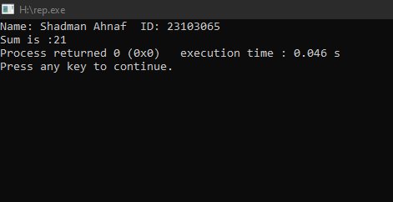

**//Sum of the series 1+2+3+4+5+6+...+N:**

#include <stdio.h>

int main() {

printf("Name: Shadman Ahnaf ID: 23103065\n");

int N;

printf("Enter the value of N: ");

scanf("%d", &N);

int sum = 0;

for (int i =1; i <= N; i++) {

sum += i;

}

printf("The sum of the series = %d\n", sum);

return 0;

}

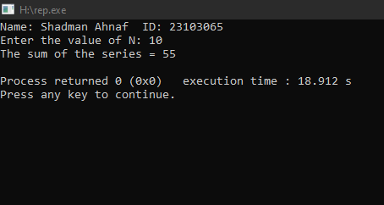

**// 1+1/2+1/3+1/4+1/5+...+1/N:**

#include <stdio.h>

int main() {

printf("Name: Shadman Ahnaf ID: 23103065\n");

int N;

printf("Enter the value of N: ");

scanf("%d", &N);

float sum = 0.0;

for (int i = 1; i <= N; i++) {

sum += 1.0 / i;

}

printf("The sum of the series = %f\n", sum);

return 0;

}

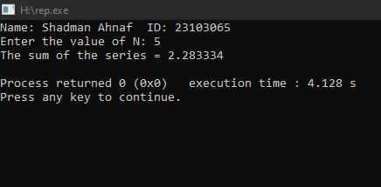

**// 9+99+999+...+N:**

#include <stdio.h>

int main() {

printf("Name: Shadman Ahnaf ID: 23103065\n");

int n,a[100];

printf("Enter the number of terms: ");

scanf("%d", &n);

a[0] = 9;

for (int i = 1; i < n; i++) {

a[i] = a[i - 1] * 10 + 9;

}

int sum = 0;

printf("Series: ");

for (int i = 0; i < n; i++) {

sum += a[i];

printf("%d ",a[i]);

}

printf("\nSum of the series up to %d terms: %d\n", n, sum);

return 0;

}

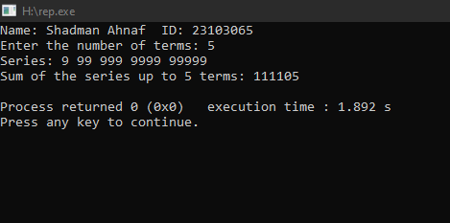

**//Fibonacci**

#include <stdio.h>

int main() {

printf("Name: Shadman Ahnaf ID: 23103065\n");

int N;

printf("Enter the value of N: ");

scanf("%d", &N);

int fib[100];

fib[0] = 0;

fib[1] = 1;

for (int i = 2; i < N; i++) {

fib[i]=fib[i-1]+fib[i-2];

}

printf("\n");

for (int i = 0; i < N; i++) {

printf("%d ", fib[i]);

}

return 0;

}

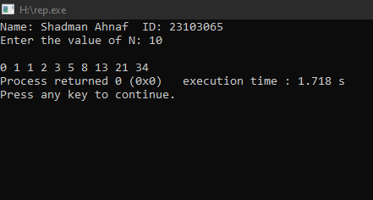

**//Write a program to print a 2D Array or a matrix.**

#include <stdio.h>

int main() {

printf("Name: Shadman Ahnaf ID: 23103065\n");

int rows, columns;

int matrix [100][100];

printf("Enter the number of rows: ");

scanf("%d", &rows);

printf("Enter the number of columns: ");

scanf("%d", &columns);

printf("Enter the elements of the matrix:\n");

for (int i = 0; i < rows; i++) {

for (int j = 0; j < columns; j++) {

printf("A[%d][%d]= ",i,j);

scanf("%d", &matrix[i][j]);

}

printf("\n");

}

printf("The matrix is:\n");

for (int i = 0; i < rows; i++) {

for (int j = 0; j < columns; j++) {

printf("%d ", matrix[i][j]);

}

printf("\n");

}

return 0;

}

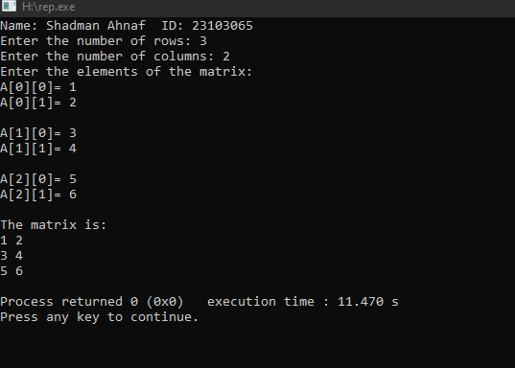

**//Write a program to take input from the user of a 2D Array or a matrix.**

#include <stdio.h>

int main() {

printf("Name: Shadman Ahnaf ID: 23103065\n");

int rows, columns;

int matrix[30][30];

printf("Enter the number of rows: ");

scanf("%d", &rows);

printf("Enter the number of columns: ");

scanf("%d", &columns);

printf("Enter the elements of the matrix:\n");

for (int i = 0; i < rows; i++) {

for (int j = 0; j < columns; j++) {

scanf("%d", &matrix[i][j]);

}

}

printf("The matrix is:\n");

for (int i = 0; i < rows; i++) {

for (int j = 0; j < columns; j++) {

printf("%d ", matrix[i][j]);

}

printf("\n");

}

return 0;

}

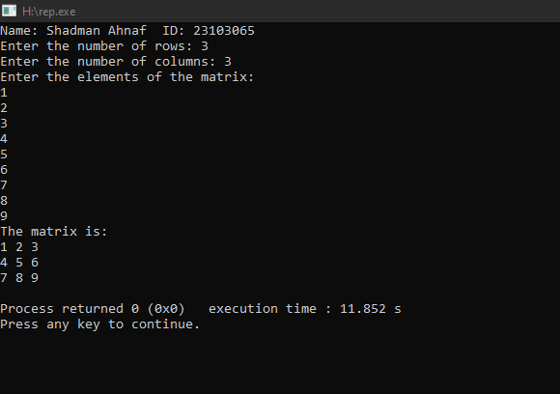

**//Add and Subtract Two Matrices:**

#include <stdio.h>

int main() {

printf("Name: Shadman Ahnaf ID: 23103065\n");

int rows, columns;

int matrix1[30][30], matrix2[30][30], sum[30][30], diff[30][30];

printf("Enter the number of rows and columns for the matrices: ");

scanf("%d %d", &rows, &columns);

printf("Enter the elements of the first matrix:\n");

for (int i = 0; i < rows; i++) {

for (int j = 0; j < columns; j++) {

scanf("%d", &matrix1[i][j]);

}

}

printf("Enter the elements of the second matrix:\n");

for (int i = 0; i < rows; i++) {

for (int j = 0; j < columns; j++) {

scanf("%d", &matrix2[i][j]);

}

}

for (int i = 0; i < rows; i++) {

for (int j = 0; j < columns; j++) {

sum[i][j] = matrix1[i][j] + matrix2[i][j];

}

}

for (int i = 0; i < rows; i++) {

for (int j = 0; j < columns; j++) {

diff[i][j] = matrix1[i][j] - matrix2[i][j];

}

}

printf("Sum of the matrices:\n");

for (int i = 0; i < rows; i++) {

for (int j = 0; j < columns; j++) {

printf("%d ", sum[i][j]);

}

printf("\n");

}

printf("Difference of the matrices:\n");

for (int i = 0; i < rows; i++) {

for (int j = 0; j < columns; j++) {

printf("%d ", diff[i][j]);

}

printf("\n");

}

return 0;

}

